Climate Risk Analysis for Coffee Systems in Latin America
Climate variability and increasing frequency of extreme events such as droughts are significantly affecting agricultural systems in Latin America, particularly coffee production. These impacts are not only related to changes in rainfall and temperature, but also to how water is distributed in space and time, and how agricultural systems respond to these changes.

We propose an integrated climate risk analysis framework that combines climate data, hydrological processes, and territorial information to support decision-making in coffee-producing regions. The approach is based on scientific research and practical applications in hydrology, drought analysis, and agricultural systems.

The methodology is structured around three main components.
The first component focuses on climate characterization and variability (Figure 1). It includes the analysis of precipitation and temperature using historical datasets and climate projections. The objective is to identify patterns, trends, and potential future scenarios. This allows understanding how climate conditions are evolving and how variability may affect agricultural systems over time (Diaz et al., 2019).

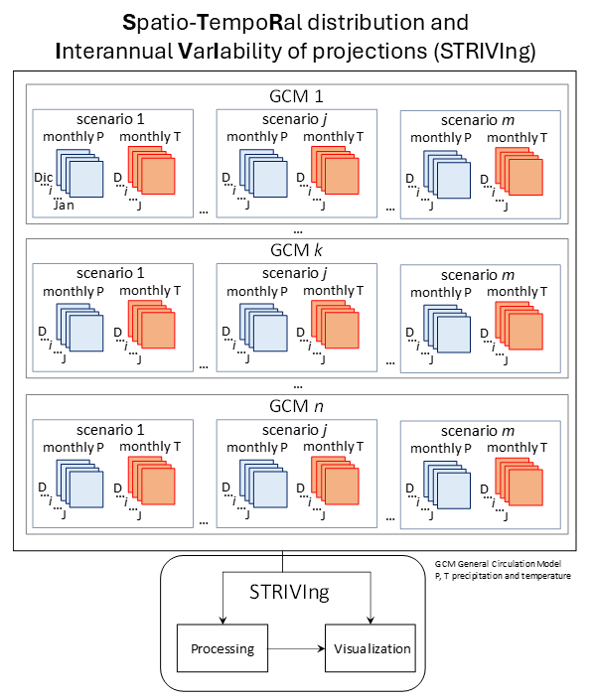
Figure 1 Schematic overview of the Spatio-TempoRal distribution and Interannual VarIability of projections (STRIVIng) analysis. GCM, General Circulation Model; P, precipitation; T, temperature

The second component addresses drought characterization and hydrological dynamics. Drought is analyzed not only as a temporal phenomenon but also in its spatial dimension. This includes the identification of drought conditions using indices based on precipitation and evapotranspiration, as well as the estimation of drought-affected areas (Diaz et al., 2026). By incorporating the spatial extent of drought, the analysis captures how large portions of territory are impacted simultaneously, which is critical for agricultural planning (Figure 2).

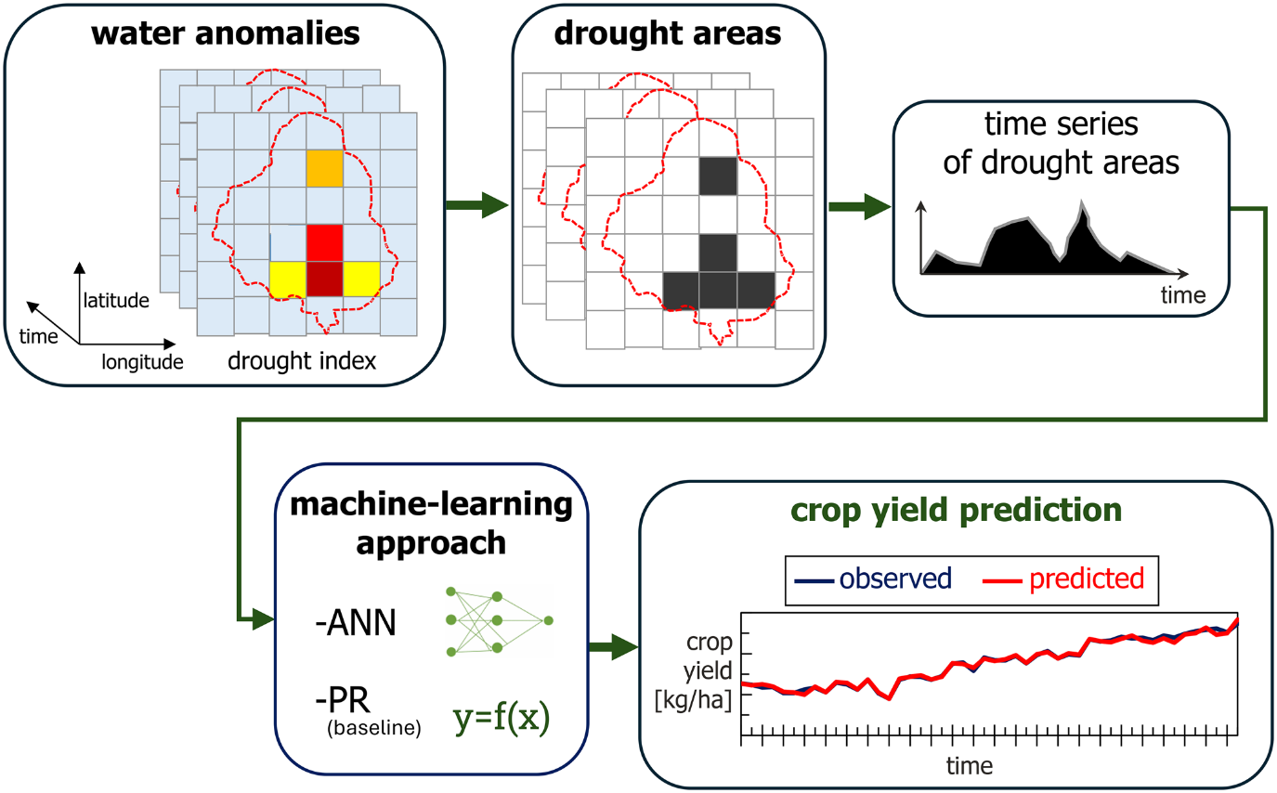
Figure 2 Crop yield predictions with drought area changes

In addition, hydrological variables such as soil moisture, runoff, and infiltration are evaluated to understand water availability within the system. These processes are directly linked to crop performance and are essential for assessing how climate variability translates into real impacts on coffee production.

The third component focuses on climate risk assessment (Figure 3). Risk is understood as the interaction between three elements: hazard, vulnerability, and resilience (Koshnazar et al., 2021). Hazard represents the intensity and frequency of drought events. Vulnerability reflects the characteristics of the production system, including land use, environmental conditions, and management practices. Resilience refers to the capacity of the system to absorb impacts and recover from adverse conditions.
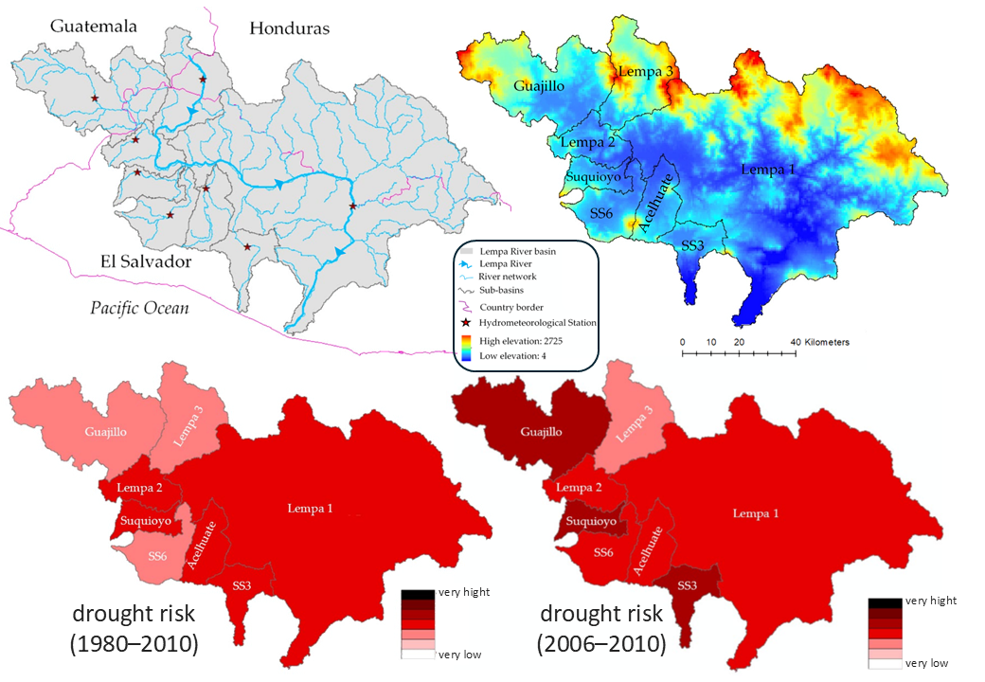
Figure 3 Spatio-temporal analysis of drought risk

By integrating these components, a climate risk index is developed to identify areas that are more exposed to climate stress and to support targeted interventions.

A key aspect of the approach is its application to coffee agroforestry systems. Coffee production in many regions relies on shade management, which plays a critical role in regulating microclimatic conditions, improving soil structure, and enhancing water infiltration. The integration of agroforestry variables into the analysis allows evaluating how different management strategies influence hydrological processes and climate risk.

This enables the comparison of alternative scenarios, such as conservative management, intensified shade systems, or degradation pathways, and their implications for water regulation and sustainability.

The outputs of the analysis include spatial maps of climate risk, temporal assessments of drought dynamics, and integrated visualizations that simplify complex data into actionable insights. These outputs are designed to support governments, producers, and organizations in decision-making processes related to land management, water resources, and climate adaptation.

The objective of this approach is not only to identify where risk occurs, but to understand why it happens and how it can be reduced through better management and planning.

This framework provides a practical and scalable tool that can be applied across different regions and crops, supporting climate resilience and sustainable agricultural development in Latin America.

References
Diaz, V., Corzo, G. and Pérez, J. R. (2019). 3 -Llarge-scale exploratory analysis of the spatiotemporal distribution of climate projections: applying the STRIVIng toolbox. In G. Corzo and E. A. Varouchakis (Eds.), Spatiotemporal Analysis of Extreme Hydrological Events (pp. 59–76). Elsevier. https://doi.org/10.1016/B978-0-12-811689-0.00003-3

Diaz, V., Osman, A. A. A., Corzo Perez, G. A., Maskey, S., and Solomatine, D. (2026). Spatiotemporal changes of drought area as input for a machine-learning approach for crop yield prediction. Hydrology Research; 57 (2): 125–149. https://doi.org/10.2166/nh.2026.150

Koshnazar, A., Corzo Perez, G.A. and Diaz, V. (2021). Spatiotemporal drought risk assessment considering resilience and heterogeneous vulnerability factors: Lempa transboundary river basin in the Central American Dry Corridor. Journal of Marine Science and Engineering; 9(4):386. https://doi.org/10.3390/jmse9040386

